**PIZZA SALES SQL QUERIES**

**A. KPI’s**

**1. Total Revenue:**

select

format(round(SUM(total_price)), 0) as Total_Revenue

from

pizza_sales_updated;



--------------------------------------------------------------------------

**2. Average Order Value**

select

round(sum(total_price)/count(distinct order_id),2) as Average_Order_Value

from

pizza_sales_updated;

--------------------------------------------------------------------------

**3. Total Pizzas Sold**

select

format(sum(quantity), 0) as Total_Pizzas_Sold

from

pizza_sales_updated;

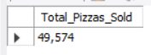

--------------------------------------------------------------------------

**4. Total Orders**

select

format(count(distinct order_id), 0) as Total_Orders

from

pizza_sales_updated;

--------------------------------------------------------------------------

**5. Average Pizzas Per Order**

select

round((sum(quantity) / count(distinct order_id)), 2) as Average_Pizzas_Per_Order

from

pizza_sales_updated;

**B. Daily Trend for Total Orders**select

dayname(order_date) as Day,

count(distinct order_id) as Orders

from

pizza_sales_updated

group by

dayname(order_date);

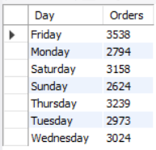

**C. Monthly Trend for Orders**

select

monthname(order_date) as Month,

count(distinct order_id) as Orders

from

pizza_sales_updated

group by

monthname(order_date);

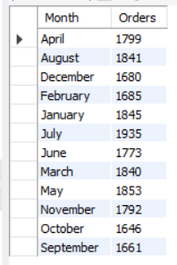

**D. % of Sales by Pizza Category**

select

pizza_category,

round(sum(total_price)/(select sum(total_price) from pizza_sales_updated)*100,2) as percentage_revenue

from

pizza_sales_updated

group by

pizza_category

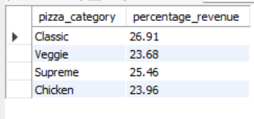

**E. % of Sales by Pizza Size**

select

pizza_size,

format(round(sum(total_price)), 0) as revenue, round(sum(total_price)/(select sum(total_price) from pizza_sales_updated)*100,2) as percentage_revenue

from

pizza_sales_updated

group by

pizza_size

order by

2 desc

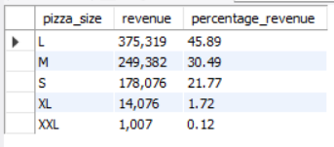

**F. Total Pizzas Sold by Pizza Category**

select

pizza_category,

format(round(sum(quantity)), 0) as Pizzas_Sold

from

pizza_sales_updated

group by

pizza_category

order by

2 desc;

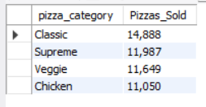

**G. Top 5 Pizzas by Revenue**

select

pizza_name,

format(round(sum(total_price)), 0) as Revenue

from

pizza_sales_updated

group by 1

order by 2 desc

limit 5;

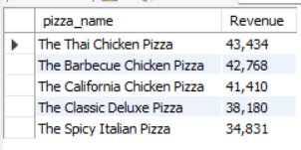

**H. Bottom 5 Pizzas by Revenue**

select

pizza_name,

format(round(sum(total_price)), 0) as Revenue

from

pizza_sales_updated

group by 1

order by 2

limit 5;

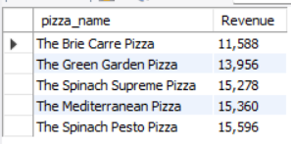

**I. Top 5 Pizzas by Quantity**

select

pizza_name,

sum(quantity) as Quantity

from

pizza_sales_updated

group by 1

order by 2 desc

limit 5;

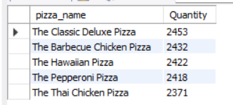

**J. Bottom 5 Pizzas by Quantity**

select

pizza_name,

sum(quantity) as Quantity

from

pizza_sales_updated

group by 1

order by 2

limit 5;

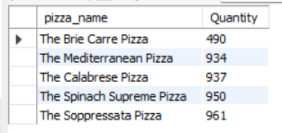

**K. Top 5 Pizzas by Total Orders**

select

pizza_name,

count(distinct order_id) as Orders

from

pizza_sales_updated

group by 1

order by 2 desc

limit 5;

**K. Bottom 5 Pizzas by Total Orders**

select

pizza_name,

count(distinct order_id) as Orders

from

pizza_sales_updated

group by 1

order by 2

limit 5;

